WW1 Dazzle Camouflage

Dazzle camouflage is made up of patterns of shapes in contrasting colours. It was used on many ships during the First World War.
It works differently to other kinds of camouflage – rather than trying to hide the ship by making it blend in to the background, it makes it much more difficult to guess how far away the ship is, how fast it’s going and in which direction it’s heading.
The dazzle patterns came in lots of different colours, and over 4000 ships were painted this way during the First World War. It’s hard to say if the dazzle camouflage worked, but it did at least make the men on the ships feel safer.
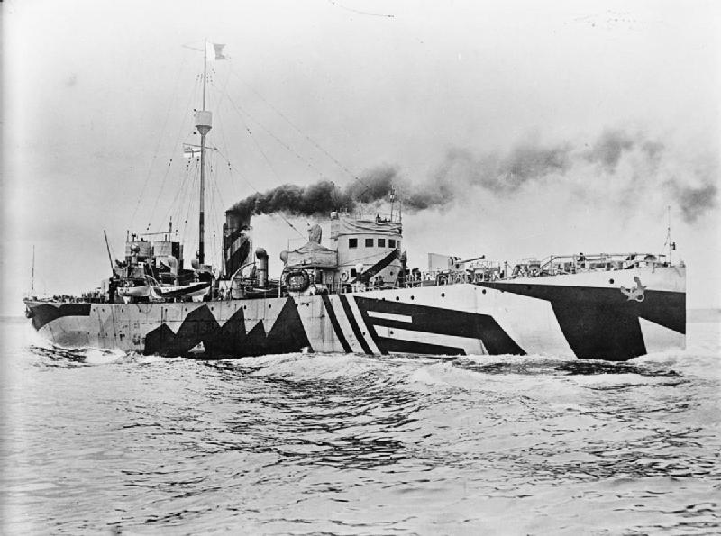
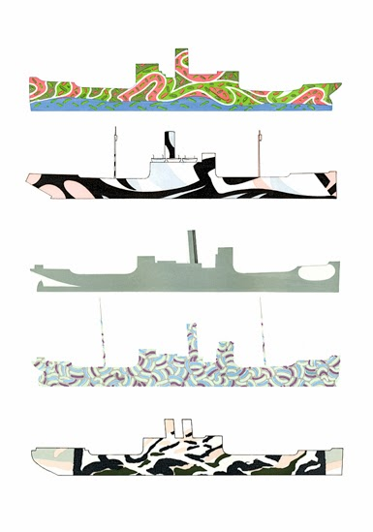
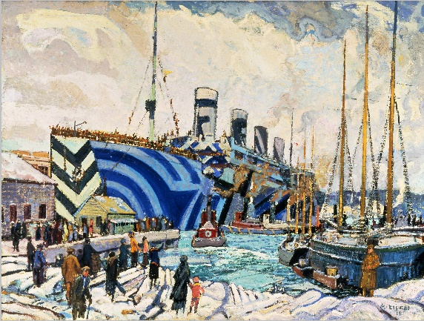
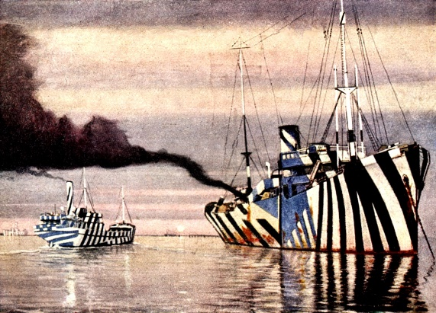
These are some examples of dazzle patterns:
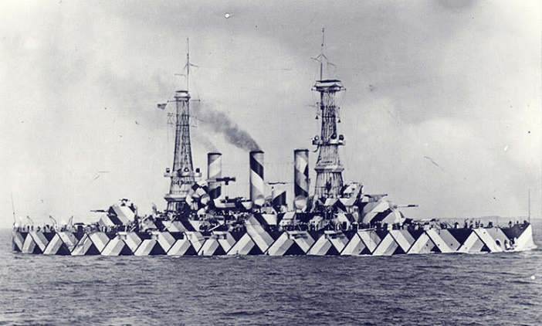
Name: …………………………………………
Design your own First World War dazzle camouflage pattern! Remember to do both sides of the ship!

